Interconnectedness in the Interbank Market

Celso Brunetti, Jeffrey H. Harris, Shawn Mankad, George Michailidis

Abstract:
In this paper we study the behavior of the interbank market during the crisis. We adopt two approaches: a correlation network, based on the correlation structure of publicly traded bank returns in our sample, and the physical network based on interbank lending transactions. The correlation network shows an increase in interconnectedness during the crisis, while the physical network highlights a marked decrease in interconnectedness. We explain these findings in terms of the economic relevance of each network structure.

JEL: G10, G21, C10.

Key Words: Correlation network, physical network, interbank market, interconnectedness

First Draft: June 4, 2014

Acknowledgements: We would like to thank for valuable discussions and comments: Kirsten Anderson, Stefano Battiston, Guido Caldarelli, Rama Cont, Michael Gordy, Erik Heitfield, Andrew Karolyi, Luigi Ruggerone, and Clara Vega, and seminar participants at Babson College, Cornell University, Hull University, the CFTC and the Board of Governors, and participants to the conference of the Society for Computational Economics, Oslo, 2014, the International Association for Applied Econometrics Annual Conference, London, 2014, the workshop on “Systemic risk and macro‐prudential regulation: perspectives from network analysis,” Bank of England, 2014, and the conference on “Behavioral Aspects in Macroeconomics and Finance,” Milan 2014. A preliminary draft of this paper was titled “The Breakdown of the Interbank Market during the Financial Crisis.” All errors are ours.
The views in this paper should not be interpreted as reflecting the views of the Board of Governors of the Federal Reserve System or of any other person associated with the Federal Reserve System. All errors and omissions, if any, are the authors’ sole responsibility

Celso Brunetti (celso.brunetti@frb.gov) is in the Division of Research and Statistics at the Federal Reserve Board; Jeffrey H. Harris (jharris@american.edu) is at American University’s Kogod School of Business; Shawn Mankad (smankad@rhsmith.umd.edu) is at University of Maryland's Smith School of Business; George Michailidis (gmichail@umich.edu) is in the Department of Statistics at the University of Michigan.

1. Introduction
The breakdown of liquidity in normally robust financial markets presents one of the enduring questions from the recent financial crisis. During the crisis, central bank intervention failed to enhance liquidity, and over short intervals, crowded out private liquidity (Brunetti, di Filippo and Harris (2011)). In addition, precautionary hoarding by relatively weak banks during the crisis appeared to exacerbate market liquidity problems as well. Given the central role that banks play in providing valuable liquidity to many markets, the interbank market plays a significant role in facilitating market liquidity.
In this paper, we study interconnectedness in the European interbank market to explore whether and how bank interconnectedness evolves during the crisis using network metrics—the correlation (Granger-causality) networks of bank stock returns (Billio, Getmansky, Lo and Pelizzon (2012)) and the physical interbank trading networks. We study how interconnectedness in these networks is affected by monetary and macroeconomic shocks related to European Central Bank (ECB) interventions and announcements of both conventional and unconventional ECB operations (see Rogers, Scotti and Wright (2014)). Further, we explore whether interconnectedness metrics help to forecast financial and economic activity.
We show that during the crisis, physical network connectedness drops significantly reflecting hoarding behavior among banks which impairs interbank market liquidity. Conversely, and similar to results in Billio et al. (2012), we find that European bank correlation networks reveal increased connectedness during the crisis. These network decompositions show that correlation and physical networks evolve differently and reflect different economic content. While the physical trading network reveals the breakdown between banks, the correlation network reveals that banks equity returns were driven by a common factor during the crisis.
Moreover, we find that correlation and physical networks respond differently to monetary and macroeconomic shocks. Early in the crisis, central banks intervened heavily, attempting to promote funding and market liquidity. Interconnectedness in physical networks adjust strongly and quickly to these central bank operations and to announcements of new information, revealing important market characteristics related to interbank trading at short (daily) horizons. Conversely, interconnectedness in correlation networks changes little in response to these events, presumably since these announcements and interventions have little impact on the common factor driving stock returns. In this light, monitoring the response of the interbank market to announcements and interventions is more valuable to policy makers interested in enhancing interconnectedness among banks.
We further explore this line of thought to test whether interconnectedness measures might serve to forecast short-term economic conditions. We show that correlation networks can identify (and forecast) periods of impending financial crises. Complementarily, physical interbank trading networks serve to identify weakening interconnectedness in the interbank system that may lead to liquidity problems.
From a policy perspective, understanding both types of networks can be useful. Correlation networks constructed from equity market returns rely on publicly-traded equity prices so cannot isolate problem banks which are privately held. Likewise, correlation networks cannot distinguish between common exposures and contagion, nor can they identify the different channels of contagion, a precondition for preventive and palliative actions by policy makers and regulators. While correlation networks might better identify systemic risk, physical networks respond to smaller exogenous shocks and are useful in identifying both systemically important and problem banks on an on-going basis. Physical networks are therefore more useful when exogenous shocks are not large enough to threaten systemic risk (i.e. most of the time). Since market liquidity depends crucially on the connectedness between banks, regulators would be well suited to monitor the interbank market for early signs of liquidity problems.
Our work contributes to the literature on networks in finance, which, broadly speaking, distinguishes between correlation networks, where edges are based on indirect links like return correlations (e.g. Diebold and Yilmaz (2014), Billio et al. (2012)), and physical networks, where direct links result from agent choices (e.g., banks A and B contract to exchange overnight funds as in Cont, Moussa and Santos (2012)). We develop an accounting framework that helps to illuminate the different nature of the two network structures. We then utilize the direct nature of trade in our data to compare and contrast correlation networks with physical networks in our empirical work.
The paper proceeds as follows. In Section 2 we provide a review of the main literature. In section 3 we provide an accounting framework which helps understanding the two different network formations. Section 4 describes our data while Section 5 describes the interconnectedness metrics from the correlation and physical networks we construct. In Section 6, we study how central bank announcements and interventions, and traditional financial variables affect network topology in a forecasting exercise. We conclude with a brief discussion in section 7.

2. Network Interconnectedness Literature
A number of research papers highlight how common holdings can drive interconnectedness within correlation networks. Much of the literature on networks in finance concentrates on how network structures are important for the propagation of shocks. Allen and Gale’s (2000) seminal paper shows that the network structure may exacerbate or attenuate contagion effects. In this literature linkages (interconnectedness) between financial institutions may occur either as a result of common holdings or as a result of direct contractual agreements.
Braverman and Minca (2014) describe how common asset holdings among banks can transmit financial distress. If two banks, A and B, hold the same asset in their portfolios and an exogenous shock forces A to liquidate the asset, the price of the asset will decline and therefore change the value of B’s portfolio. In this way, common asset holdings generate networks that transmit shocks between (and among) banks. While links in the network of common asset holdings are not readily specified in bank balance sheets, they may be estimated by stock market price linkages.
In line with equity market reactions, Braverman and Minca (2014) show that the severity of contagion depends on both common holdings and the liquidity of these common holdings. In their network model, the higher the number of common assets in the portfolios the higher is the possibility of contagion (a point first introduced by Shaffer (1994)). In a similar vein, Lagunoff and Schreft (1998) develop a game-theoretic model which shows that as economies increase in size, diversification opportunities also increase which, in turn, reduces network fragility. However, if the increase exceeds a given threshold, the high level of interconnectedness may increase financial fragility.
Indeed, Cont and Wagalath (2011) show that realized correlations in equity indices increased dramatically with the collapse of Lehman Brothers on September 15, 2008. They conjecture that the increased correlation resulted from the liquidation of large positions by market participants (fire sales) and develop a model in which returns are driven by both fundamentals and liquidity. They highlight the limits of diversification—even in the absence of correlation between fundamentals, liquidity correlations among large assets can generate correlated asset returns, “thus losing the benefit of diversification exactly when it is needed.” (p.4).
Cabrales and Gottardi (2014) model contagion as the transmission of a pathologic disease, linking firms as they exchange assets to meet capital requirements. They note that there is a trade-off between risk-sharing and contagion among firms. Similarly, De Vries (2005) claims that banks, by holding similar portfolios, are exposed to the same market risks so that bank equity returns are asymptotically dependent. Likewise, Acharya and Yorulmazer (2008) show that if banks hold stakes in the same companies (e.g. for diversification purposes) bank equities are necessarily interdependent.
A second burgeoning literature on financial networks examines contractual agreements similar to our physical network constructed from interbank trades. For example, Acemoglu, Ozdaglar and Tahbaz-Salehi (2013) find that financial contagion is a function of the network structure. They confirm (as in Allen and Gale (2000)) that a network where all banks are connected is less fragile than an incomplete network for small exogenous shocks. However, for large shocks, a more interconnected network facilitates contagion, creating a more fragile system. Similarly, Gai, Haldane and Kapadia (2011) present a theoretical framework to identify tipping points in complex systems, whereby smalls shock can have large consequences.
Some works consider both correlation and physical networks. Cifuentes, Ferrucci and Shin (2005) construct a model that incorporates two channels of contagion: direct linkages through the interbank market and indirect linkages through common holdings. Similarly, Caccioli, Farmer, Foti and Rockmore (2013) analyze both the network of common holdings and the physical network and show that in a crisis, contagion is mainly driven by common holdings but it is amplified by trading the physical network—i.e. both networks contribute to systemic risk.
Most of this literature highlights the fact that common asset holdings, reflected in correlation networks, are the main source of systemic risk (Elsinger, Lehar and Summer (2006)) and that interbank lending (the physical network of bank connections) plays only a marginal role. Conversely, we analyze theses networks from a different angle. We are aim to quantify the information content of these two network structures to better understand how policy decisions might be more effective in ameliorating systemic risk and enhancing market liquidity in times of crisis.

3. An Accounting Framework
In order to highlight the two different network formations, we adopt a simple accounting framework (following Shin (2009a, 2009b) and Elliott, Golub and Jackson (2014)). We consider a simple financial system in which banks connect lenders to borrowers as intermediaries, collecting deposits from households and firms and investing the deposits in a portfolio of assets, including loans to the household sector (via mortgages and consumer debt) and firms.
We introduce now some notation:
- $y_{i,k}$ denotes the market value of bank i’s assets—including loans to firms and households as well as k asset classes (equities, bonds, commodities, etc.).
- $w_{i,k}$ is the weight invested in each of the k assets by bank i; $\sum_{k}{w_{i,k}=1};$
- $x_{i}$ denotes the total value of liabilities of bank i held by other banks;
- $x_{i,j}$ is the value of bank i’s liabilities held by bank j;
- $π_{i,j}$ is the share of bank i’s liabilities held by bank j;
- $e_{i}$ indicates the market value of bank i’s equity;
- $d_{i}$ is the total value of liabilities of bank i held by non-banks.
Hence, banks i’s balance sheet is given by

Assets | Liabilities
$$\sum_{k}{w_{i,k}y_{i,k}}$$ | $$e_{i}$$
 | $$x_{i}$$ | (1)
$$\sum_{j}{{x_{j}π}_{i,j}}$$ | $$d_{i}$$

and bank i’s balance sheet identity is
$$\sum_{k}{w_{i,k}y_{i,k}}+\sum_{j}{x_{j}π_{i,j}}=e_{i}+x_{i}+d_{i}\text{ (2)}$$
The left hand side is the value of all bank i’s assets which is equal to the market value of bank i’s portfolio, first term, and to the funds lent by bank i to other banks (interbank lending), second term.
From equation (2) we can express the vector of interbank debt as follows
$$X=ΠX+WY-E-D \text{(3)}$$
and
$$\left(I-Π\right)X=WY-E-D \text{(4)}$$
The left hand side is the interbank market which, according to (4), depends on the market value of the portfolio of assets held by banks, the market value of bank equities and the value of bank liabilities held by non-banks. The interbank market is dynamic, with daily trading (overnight loans represent the overwhelming majority—92.3%—of contracts in e-Mid) in response to their funding needs (commonly linked to minimum reserve requirements, margin calls, or shortages needed to fulfill contractual obligations, represented by the first term of the right hand side of (4)). Bank equity (E) changes over time may also drive interbank lending through the second term on the right hand side of (4).
Following Shin (2009a), we assume that the debt liabilities to non-banks are expected to be sticky—i.e. D is will move very slowly. D represents debt claims on the banking sector by households, mutual and pension funds and other non-bank institutions, so while D varies over time, changes to D are less likely to drive interbank lending.
Given the accounting identity that governs the full system of banks, we represent the adjacency matrix of the interbank lending market as follows.
 | Bank 1 | Bank 2 | … | Bank s
Bank 1 | 0 | $$π_{1,2}$$ | … | $$π_{1,s}$$
Bank 2 | $$π_{2,1}$$ | 0 | … | $$π_{2,s}$$
 | … | … | …
Bank s | $$π_{s,1}$$ | $$π_{s,2}$$ | … | 0

From equation (4) we build the consolidated balance sheet of the banking sector as whole where assets and liabilities are aggregated across banks. Given that $x_{i,j}$ is a liability for bank i but an asset for bank j, the aggregated balance sheet does not include any interbank claims. Hence, (1) becomes
Assets | Liabilities
$$\sum_{i}{\sum_{k}{w_{i,k}y_{i,k}}}$$ | $$\sum_{i}{e_{i}}$$
 |  | (5)
 | $$\sum_{i}{d_{i}}$$

and the balance sheet identity is now
$$E=WY-D \text{(6)}$$
Equations (4) and (6) highlight how the two networks subsume different information sets which represent our main object of investigation. The main difference between the two networks emanate from the aggregation which is required in the correlation network. Below we formally test whether and how economic fundamentals and shocks affect interconnectedness in the two network structures.
For the correlation network, edges are a function of the variance-covariance matrix of bank equity returns. Following Billio et al. (2012), we first compute rate of returns of bank i’s equity
$$r_{i,t}=ln\left(\frac{e_{i,t}}{e_{i,t-1}}\right)$$
and then filter $r_{i,t}$ using a standard GARCH(1,1) model. For each pair of bank returns, $U_{t}$, we run the following VAR
$$Φ\left(L\right)U_{t}=V_{t} (7)$$
where $V_{t}\sim Λ\left(0,Σ\right)$, and test the following null:
$$H_{0}:\hat{Φ}\left(L\right)=0 (8)$$
where $\hat{Φ}\left(L\right)$ refers to the off-diagonal terms of $Φ\left(L\right)$ estimated by OLS. This is a standard Wald test with covariance matrix equal to $V^{'}Σ^{-1}V$. Rejecting the null in (8) produces an edge between the returns of the two banks in $U_{t}$.
Note that while the physical network of interbank trades is directly observable, the correlation network based on equity returns is the result of a testing procedure which, in addition to the classic type I and II errors, is a function of the model specification in (7).

4. Data
The data required to construct correlation and physical networks highlight the unique composition of both networks. Our e-MID physical trading data includes 207 unique banks, with a diminishing number over time as the crisis progressed. However, only 29 of these banks are publicly-traded, so construction of correlation networks is limited to this smaller set of banks. Only in rare cases will a partial physical network of 29 banks fully capture how they trade with each other, since their trades with the other 178 banks would be excluded.
Therefore, we utilize all available data and construct the physical network using all 207 banks and construct the correlation network from the set of 29 publicly-traded European banks in our e-MID dataset from January 2006 through March 2010. We examine the full time period as well as four sub-periods: 1) a pre-crisis period from January 2, 2006 until August 7, 2007; 2) the first crisis period (pre-Lehman) from August 8, 2007 until September 12, 2008; 3) the second crisis period (post-Lehman) from September 16, 2008 through April 1, 2009; and the “tentative recovery” post-crisis period, from April 2, 2009 through March 31, 2010. This last period was characterized by a weak recovery in Europe—the recession officially ended in the third quarter of 2009, thanks largely to fiscal and monetary measures to stimulate the economy. The beginning and ending dates of our sample are limited by our access to e-MID data. We adopt two data frequencies: daily and monthly.
Daily summary statistics for the rate of returns are reported in Table 1. In the pre-crisis period, rate of returns are positive and exhibit low volatility. In the crisis periods returns are highly negative and exhibit very large volatility. Bank equity returns are positive again in the post-crisis period albeit still very volatile.
To construct physical networks we employ e-MID trading data from the only electronic regulated interbank market in the world. Each e-MID transaction includes the time (to the second), lender, borrower, interest rate, quantity, and an indication of which party is executing the trade. The e-MID market is open to all banks admitted to operate in the European interbank market and non-European banks can access the market through their European branches. We observe 207 unique banks and 364,917 trades in the data. At the beginning of our sample, internal estimates from e-MID reveal that this market covers between 20% and 30% of the interbank market in the Euro area. However, this percentage has been dropping since the crisis. Accordingly, we find a decline in the average number of banks in the data from 129 to 113 to 91 to 77 across our four sub-periods. The automated trade processing features in e-MID allow us to accurately assess and examine the interbank trading connections between banks in this market (at least those executed through the e-MID system).
Table 2 reports daily e-MID market summary statistics, by sub-period, for price changes, effective spreads, volume, trade imbalances, market concentration (a Herfindahl index) and signed volume. As shown, daily price changes are consistently negative, with greater negative changes during the two crisis periods. Volatility rises dramatically during the crisis and remains somewhat elevated in the last post-crisis sub-period as illustrated in Figure 1.
Effective spreads, in Table 2, remain relatively stable across our sample period, suggesting that interbank market liquidity did not suffer appreciably during the crisis. Average daily volume, on the other hand, varies significantly and ranges from 927 to almost 42,000 contracts per day. The top right panel of Figure 1 shows clearly that volume drops substantially over time resulting in post-crisis volume less than 20 percent of pre-crisis volume.
The lower left panel of Figure 1 plots trade imbalances (scaled by volume) over time and shows that imbalances increase over time, a result driven by the concurrent decline in volume. Market concentration, as measured by the Herfindahl index, also rises consistently over our sample period (see bottom right panel of Figure 1), reflecting greater concentration among banks using e-MID. Signed volume is negative throughout our sample period, indicating that banks actively use e-MID for selling funds.

5. Network Interconnectedness
We compute various measures of interconnectedness by utilizing the correlation networks (from bank stock returns) and physical networks (from e-MID trading data). Our correlation networks infer edges between banks through Granger-causality tests between stock returns (as in Billio et al. (2012)). Our physical networks are formed by direct trades in the e-MID interbank market. We emphasize the fact that the 29 banks composing the correlation network are also part of the physical network, but their connections in one network do not necessarily imply the same connections in the other.
For the correlation network, we utilize returns for individual banks to establish Granger-causality links between banks. In particular, if the return of bank A Granger-causes the return of bank B, then we draw a directed edge from A to B. Granger-causality tests are run using both monthly data, 36-month rolling windows, and daily data, 44-day rolling window.
The physical network maps lenders to borrowers over each month. Specifically, if Bank B borrows from Bank A within the time interval of interest, then an edge is drawn from A to B. In this manner interbank lending networks capture funding liquidity by distinguishing banks providing funds from banks receiving funds. Similar to the correlation network, we construct daily and monthly physical networks which account for all e-Mid transactions during a day or a month.
We extract various network interconnectedness metrics and display these results in Table 3, taking care to normalize these statistics by the number of banks in the network, so that appropriate comparisons can be made between each network on these metrics. First, we estimate the degree of each network, defined as the number of connections as a proportion of all possible connections. We follow the notation in Billio et al. (2012) and introduce the indicator function $A→B$ denoting whether an edge exists from bank A to bank B. Degree is then defined as
$Degree= \frac{1}{N(N-1)}\sum_{A=1}^{N}{\sum_{B≠A}{A→B}}$, (9)
where N is the total number of banks (nodes) in the network. Degree is a network-wide measure used by Billio et al. (2012) to estimate the risk of a systemic event. Within the physical network, lower average degree may indicate a lower level of liquidity on e-MID.
Our second metric of connectivity is the clustering coefficient, which measures how often triangular connections occur or the probability that neighbors of a bank are themselves connected. The clustering coefficient (CC) is defined as
$CC=\frac{3×number of connected triples}{number of possible connected triples}$, (10)
where a connected triple means any three banks A, B and C such that $A→B$, $A→C$ and B$→C$. Clustering coefficients approaching the maximum value of 1 would indicate higher levels of connectedness.
The third measure of network connectivity, the largest strongly connected component (or LSCC), is the proportion of banks that are connected to other banks by following directed edges on the network scaled by the total number of banks in the network. Hence, the LSCC also measures the level of interconnectedness in the network with an LSCC of one indicating that any bank can reach every other bank while an LSCC closer to zero indicates a highly fragmented network.
Our fourth measure of interconnectivity we utlilize is closeness, which measures how many steps are between banks on average. To construct this measure, let $C_{AB}$ be the length of the shortest path from bank A to bank B, where $C_{AB}=N-1$ if there is no path from bank A to bank B. Then closeness is defined as
$closeness= \frac{1}{N(N-1)}\sum_{A=1}^{N}{\sum_{B≠A}{C_{AB}}}$. (11)
Closeness is normalized to be between 0 and 1, where larger values indicate larger relative distance between banks on the network.
As shown in Table 3, the variation of monthly network statistics in the correlation network is larger than that in the physical network. Within correlation networks, the change in degree and clustering coefficient from pre-crisis to the first crisis period is statistically significant, whereas LSCC and closeness change significantly only in the second crisis period. Following these changes, connectedness (as captured by these metrics) remains elevated through the last sub-period.
Through the lens of the physical market, however, connectedness appears to have been significantly diminished. Connectivity in the physical network drops significantly at the outset of the crisis and remains below pre-crisis levels through the post-crisis period. In contrast to the other metrics of interconnectivity, closeness increases in the physical network. By construction, larger values of closeness indicate decreased connectivity, marking an increasingly fragmented physical network.
These disparate results show that the correlation and physical networks capture different notions of connectedness. The crisis permanently diminished interconnectedness between banks in the physical interbank trading network, while interconnectedness increases when measured via indirect stock return correlation networks. While the physical connections between banks in the interbank market are diminished, these same banks are indirectly connected to a common factor that does not affect interbank trading. Indeed, Cont and Wagalath (2011, 2012) that use a structural equation model to link the behavior of large institutional investors to equity correlations, the basis of our correlation networks.
Figure 2 displays the monthly time series of the network measures from the two types of networks and clearly shows that connectivity increases in the correlation network at the onset of the crisis 1 sub-period and keeps rising in the subsequent sub-periods. Overall we find that interconnectedness increases after the failure of Lehman Brothers in the correlation network, but decreases in the physical network. Lagunoff and Schreft (1998) claim that: “A financial crisis is a breakdown of the economy’s financial linkages, a collapse of all or part of the financial structure.” (p 2). The physical network clearly captures this phenomenon.
The two networks also behave differently also in other respects. As Figure 3 shows, correlation networks are sparser than the physical networks in the pre-crisis period, perhaps expected with only 29 banks in the correlation network. Despite the lower number of banks, however, the correlation network becomes more interconnected throughout our sample period. Conversely, the physical network in the post-crisis period is characterized by a “core” of banks highly interconnected and several banks which have a low degree of interconnectedness.
To further study the evolution of the two network structures during the crisis, we identify individual banks that contribute most to market connectivity using the matrix factorization-based technique developed in Mankad and Michailidis (2013) and Mankad, Michailidis, and Brunetti (2014). Figure 4 displays the importance of each bank over time and shows that a small subset of banks contributed most to physical network connectivity during the crisis and beyond. Interestingly, some banks became more connected in the physical network even while the overall market became less connected. However, in the correlation network, the onset of the crisis brought a spike in connectivity among all bank returns. Clearly, physical and correlation networks have different dynamics.

6. Economic Shocks and Network Connectedness
We explore these differing dynamics further by analyzing how these network structures reflect economic shocks. Given that markets react to announcements (e.g. Faust, Rogers, Wang and Wright, (2007)), we aim to compare and contrast how announcements are reflected in the stock market and interbank market. We are particularly interested in two types of shocks. The first type refers to European Central Bank (ECB) announcements and interventions. During our sample period, the ECB adopted both conventional and unconventional monetary interventions. In particular, for the ECB interventions we distinguish among Long Term Refinancing Operations (LTRO), Main Refinancing Operations (MRO) and Other Type (OT) of ECB operations. For the announcements we follow Rogers, Scotti and Wright (2014) and consider conventional and unconventional ECB operations.
The second type of shocks we consider refer to more general changes in macroeconomic conditions. We first capture these shocks using the real activity indices developed in Scotti (2013): the surprise and uncertainty indices. The surprise index summarizes recent economic data surprises and captures optimism/pessimism about the state of the economy. The uncertainty index measures uncertainty related to the state of the economy. We also consider the evolution of the European stock market, captured by the Dow-Jones index for Europe and the London Interbank Offered Rate (LIBOR).
To fully capture the ECB shocks we use daily data. Hence, for this exercise we adopt daily networks. Following Kilian and Vega (2011), we estimate the following models for each sub-period and for each network type:
$$y_{t+k}=$$
$α+ β_{1}U_{t}+β_{2}S_{t}+β_{3}DJST_{t}+ β_{4}EONIA_{t}+ β_{5}LTRO_{t}+ β_{6}MRO_{t}+ β_{7}OT_{t}+γy_{t-1}+ ε_{t}$ (12)

$$y_{t+k}=$$
$α+ β_{1}U_{t}+β_{2}S_{t}+β_{3}DJST_{t}+ β_{4}EONIA_{t}+ β_{5}Annoucements_{t}+γy_{t-1}+ e_{t}$ (13)
where $y_{t+k}$ represents network statistics (closeness, clustering coefficient, degree and LSCC) on day t, $U_{t}$ is the economic uncertainty index and $S_{t}$ the economic surprise index from Scotti (2013),$DJST_{t}$ is the DJ Europe stock index, $EONIA_{t}$ is the Euro OverNight Index Average, $LTRO_{t}$ is a dummy for ECB Long Term Refinancing Operations, $MRO_{t}$ is a dummy for ECB Main Refinancing Operations, $OT_{t}$ is a dummy for Other Type of ECB operations, and ${Announcements}_{t}$ is a dummy variable which captures both conventional and unconventional ECB intervention announcements. $U_{t}$, $S_{t}$, $DJST_{t}$ and $EONIA_{t}$ are proxies for fundamentals shocks in the economy while $LTRO_{t}$, $MRO_{t}$, $OT_{t}$ and ${Announcements}_{t}$ captures monetary policy shocks.
Figure 5 shows the $R^{2}$for each network type, over all dependent variables and forecasting horizons, k, for equation (12). With the exception of the last row (LSCC), it seems that both networks capture the same information before the crisis. However, there is a clear pattern showing that the physical network reacts more to ECB interventions and macro-economic shocks during the crisis and following.
Figure 6 shows the estimated coefficients for the regressions in equation (12). The correlation network reacts to shocks captured by the $EONIA_{t}$which plays an important role in explaining the structure of the correlation network in all sub-periods. EONIA and the uncertainty index are the most important factors in the physical network and seem so dominant that they overshadow the other variable effects. This evidence is consistent with the vast literature showing that uncertainty has important effects on the real economy. Our evidence shows that the network structures we study react to uncertainty shocks as well.
Indeed Figure 7 displays the partial $R^{2}$from equation (12) related to the announcements alone (during the pre-crisis period, no announcement were made). Importantly, early in the crisis the incremental information impounded by the announcements, conditional on the general impact of macroeconomic factors, is contemporaneously reflected in the correlation network. This conditional impact is reflected only with a lag in the physical network. However, the magnitude of the impact in the physical market is often significantly larger for the physical network.
In Figure 8 we distinguish between macroeconomic shocks and monetary policy shocks (of course the two might be correlated) and formally test whether the network structure of the correlation and of the physical networks react to these two types of shocks. Our null hypotheses are that all macro shocks have no effect on the network structure (i.e. the coefficient of $U_{t}$, $S_{t}$, $DJST_{t}$ and $EONIA_{t}$ in equations (12) and (13) are jointly equal to zero), and, similarly, all ECB shocks have no impact on the network structure (i.e. the coefficients of ${LTRO}_{t}$, ${MRO}_{t}$ and ${OT}_{t}$ in Equation (12) are jointly equal to zero in equation (12), and the coefficient for ${Announcements}_{t}$ in equation (13) is equal to zero). A p-value close to zero indicates rejection of the null—e.g. macro and/or ECB shocks are statistically relevant. In the pre-crisis period, macroeconomic shocks are important for the correlation network (except in degree) at all forecasting horizons, while the physical network reacts to macroeconomic shocks only at the 3-5 day horizon.
Similarly, Figure 9 documents the partial $R^{2}$from equation (12) related to the operations alone during our sample period. Conditional on the macroeconomic environment, the physical network generally responds more to central bank operations. During the pre-crisis period, the incremental explanatory power from operations in the physical network is greatest contemporaneously, tailing off over subsequent months. During the crisis periods and beyond these effects are diminished or negligible (depending on the connectedness metric).
In the crisis and post-crisis periods, the physical network is more responsive to macroeconomic shocks than the correlation network, consistent with Puliga, Caldarelli, and Battiston (2014) who document that during the crisis increased correlations in credit default swap premia depend on macroeconomic factors. The F-tests for the ECB interventions in equation (12) shows that these type of shocks are important to only physical networks. In particular, the physical network reacts to ECB interventions mainly at short horizons from 0 to 3 days.
To further isolate the effect of ECB shocks, we also examine the hypotheses above within a partial regression analysis setting. Specifically, let ${\hat{y}}_{t+k|1:4}$ denote the fitted values resulting from estimating the following regression model
$y_{t+k}= α+ β_{1}U_{t}+β_{2}S_{t}+β_{3}DJST_{t}+ β_{4}EONIA_{t}+γy_{t-1}+ ε_{t}$. (14)
We test the significance of variables in the following regression models
$y_{t+k}-{\hat{y}}_{t+k|1:4}= β_{0}+ β_{5}LTRO_{t}+ β_{6}MRO_{t}+ β_{7}OT_{t}+ e_{t}$ (15)
$y_{t+k}-{\hat{y}}_{t+k|1:4}= β_{0}+ β_{5}Annoucements_{t}+ v_{t}$. (16)
Figure 10 depicts the F-test for the null $H_{0}: β_{5}=β_{6}=β_{7}=0 | β_{1},β_{2},β_{3}, β_{4}≠ 0$ for equation (15). In all sub-periods, the correlation network responds to ECB interventions only contemporaneously (i.e. k = 0). This is also true for the physical network. However, interconnectedness in the physical network (measured by the clustering coefficient and degree) reacts to ECB interventions contemporaneously and across subsequent days in the crisis and post-crisis sub-periods.
Overall, Figures 5-10 show that the physical and correlation networks respond differently to shocks and therefore reflect different information sets. To the extent that correlation networks based on stock prices are more forward looking, we conjecture that the relatively muted response is related to anticipated macroeconomic changes. Conversely, since our physical networks respond more strongly to shocks, we surmise that the physical network more closely reflects connectedness between and among banks, a connectedness that is more sensitive to economic shocks.
Given that correlation and physical networks capture different phenomenon, we assess whether and how network topology might help to serve policy makers in forecasting relevant macroeconomic variables. In this regard, we utilize monthly networks and consider several of macro variables including
- hard information, such as Industrial Production (IP) and Retail Sales (RS);
- soft information, such as the Purchasing Manager Index (PMI) —Bańbura and Rünstler (2011) show that soft information may be important in forecasting);
the spread between the Euro Interbank Offered Rate appears to provide valuable information about the future state of the economy. In this regard, we suggest that monitoring interbank markets would provide valuable gauge for assessing the state of the bank sector and effectiveness of interventions.

7. Concluding Remarks
During the recent financial crisis, market dynamics changed dramatically, with some markets seizing up as market uncertainty and asymmetric information between banks created unprecedented problems in the world economy. In this paper we analyze the detailed trading data from the European (e-MID) interbank market to better understand how interbank trading reflected these economic problems. We construct and examine physical networks of trade that allow us to examine bank connectedness over time. Further, we compare and contrast correlation networks (constructed with Granger-causality between stock returns) with physical networks (constructed from interbank trades) to better interpret results from each.
We demonstrate that correlation and physical networks reflect important, but different, economic conditions in the European banking sector. During the crisis, physical bank networks reveal a breakdown in connectivity in the interbank market. Interestingly, correlation networks show increased comovements in market returns during the crisis that have been interpreted as an increase in connectivity, a connectivity that we ascribe to a common factor unrelated to interbank trading.
Moreover, correlation and physical networks respond differently to monetary and macroeconomic shocks. Interconnectedness in physical networks adjust strongly and quickly to central bank operations and to announcements of new information, revealing important markers of liquidity at short (daily) horizons. Conversely, while interconnectedness in correlation networks marks the onset of the crisis, this metric changes little in response to central announcements and interventions.
Our results demonstrate that correlation networks can identify (and forecast) periods of impending financial crises. Complementarily, physical interbank trading networks serve to identify weakening interconnectedness in the interbank system that may lead to liquidity problems. Moreover, physical networks can identify systemically important and problem banks on an on-going basis. From a policy perspective, monitoring both types of networks can be useful.

References
Acemoglu, D., O. Asuman and A. Tahbaz-Salehi, 2013. Systemic Risk and Stability in Financial Networks. NBER Working Paper, No. 18727

Acharya, V., L.H. Pedersen, T. Philippon, and M. P. Richardson, 2010. FRB of Cleveland Working Paper No. 10-02

Acharya V., T. Yorulmazer, 2008. Cash-in-the-Market Pricing and Optimal Resolution of Bank Failures, Review of Financial Studies 21, 2705-2742.

Achlioptas, D., Clauset, A., Kempe, D., & Moore, C. (2009). On the bias of traceroute sampling: Or, power-law degree distributions in regular graphs. Journal of the ACM 56, 21.

Adrian, T. and H-S. Shin, 2010. Liquidity and Leverage. Journal of Financial Intermediation 19, 418-437.

Allen, F., and A. Babus, 2010. Networks in Finance. In Network-based Strategies and Competencies, edited by Paul Kleindorfer and Jerry Wind, Wharton School Publishing.

Allen, F. and D. Gale, 2000. Financial Contagion. Journal of Political Economy 108, 1-33.

Allen, F., A. Babus and E. Carletti, 2010. Financial Connections and Systemic Risk. National Bureau of Economic Research, working paper 11177.

Bańbura, M., and G. Rünstler, 2011. A look into the factor model black box: publication lags and the role of hard and soft data in forecasting GDP. International Journal of Forecasting 27, 333-346.

Barigozzi,, M. and C. T. Brownlees, NETS: Network Estimation for Time Series (May 18, 2014). Available at SSRN: http://ssrn.com/abstract=2249909 or http://dx.doi.org/10.2139/ssrn.2249909

Billio, M., M. Getmansky, A. Lo and A. Pelizzon, 2012. Econometric measures of connectedness and systemic risk in the finance and insurance sectors. Journal of Financial Economics 104, 535-559.

Bloom, N., 2009. The impact of uncertainty shocks. Econometrica 77, 623-685.

Braverman, A. and A. Minca, Networks of Common Asset Holdings: Aggregation and Measures of Vulnerability (January 17, 2014). Available at SSRN: http://ssrn.com/abstract=2379669 or http://dx.doi.org/10.2139/ssrn.2379669

Brunetti, C., M. di Fillippo and J. H. Harris, 2011. Effects of Central Bank Intervention on the Interbank Market during the Sub-Prime Crisis. Review of Financial Studies 24, 2053-2083.

Cabrales, A., P. Gottardi, and F. Vega-Redondo, 2014. Risk-sharing and Contagion in Networks (March 16, 2014). CESifo Working Paper Series No. 4715. Available at SSRN: http://ssrn.com/abstract=2425558.

Caccioli, F., J.D. Farmer, N. Foti and D. Rockmore, 2013. How interbank lending amplifies overlapping portfolio contagion: A case study of the Austrian banking network. arXiv preprint, arXiv:1306.3704.

Chandrasekaran, V., Parrilo, P. A., & Willsky, A. S. (2012). Latent Variable Graphical Model Selection via Convex Optimization. Annals of Statistics 40, 1935-1967.

Cifuentes, R., C. Ferrucci and H.S. Shin, 2005. Liquidity Risk and Contagion. Journal of European Economic Association 3, 556-566.

Cont, R. and L. Wagalath, Fire Sales Forensics: Measuring Endogenous Risk (May 4, 2012). Available at SSRN: http://ssrn.com/abstract=2051013

Cont, R. and L. Wagalath, 2013. Running for the Exit: Distressed Selling and Endogenous Correlations in Financial Markets. Mathematical Finance 23, 718-741.

Cont, R., A. Moussa and E. B. Santos, 2013. Network Structure and Systemic Risk in Banking Systems. Handbook of Systemic Risk. Editor(s): Fouque, Langsam, Cambridge University Press.

De Vries, C., 2005. The Simple Economics of Bank Fragility. Journal of Banking and Finance 29, 803-825.

Delpini, D., S. Battiston, M. Riccaboni, G. Gabbi, F. Pammolli and G. Caldarelli, 2013. Evolution of Controllability in Interbank Networks. Scientific Report 3, 1626.

Diebold, F. X. and K. Yilmaz, 2014. On the network topology of variance decompositions: Measuring the connectedness of financial firms. Journal of Econometrics 182, 119-134

Elliott, M., B. Golub and M. O. Jackson, 2014. Financial Networks and Contagion. American Economic Review 104, 3115-53.

Elsinger, H., A. Lehar and M. Summer, 2006. Risk Assessment for Banking Systems. Management Science 52, 1301-1314.

Forbes, K.J. and R. Rigobon, 2002. No Contagion, only Interdependence: Measuring Stock Market Co-movements. Journal of Finance 57, 2223-2261.

Faust, J., J. H. Rogers, S.-Y. B. Wang and J. H. Wright, 2007. The high-frequency response of exchange rates and interest rates to macroeconomic announcements. Journal of Monetary Economics 54, 1051-1068.

Gai, P., A. Haldane and S. Kapadia, 2011. Complexity, Concentration and Contagion. Journal of Monetary Economics 58, 453-470.

Handcock, M. S., & Gile, K. J. (2010). Modeling social networks from sampled data. The Annals of Applied Statistics 4, 5-25.

Hatzopoulos, V., G. Iori, R.N. Mantegna, S. Micciche and M. Tumminello, 2014. Quantifying preferential trading in the e-MID interbank market. Quantitative Finance, ISSN 1469-7688 (In Press).

Iori, G., R.N. Mantegna, L. Marotta, S. Micciche', J. Porter and M. Tumminello, 2014. Networked relationships in the e-MID Interbank market: A trading model with memory. Journal of Economic Dynamics and Control 50, 98-116.

Jackson, M. 2008. Social and Economic Networks. Princeton University Press, Princeton, NJ, USA.

Kilian, L. and C. Vega, 2011. Do Energy Prices Respond to U.S. Macroeconomic News? A Test of the Hypothesis of Predetermined Energy Prices, The Review of Economics and Statistics, MIT Press 93, 660-671, May.

Lagunoff, R. and L. Schreft, 2001. A Model of Financial Fragility. Journal of Economic Theory 99, 220-264.

Leduc, S. and Z. Liu, 2012. Uncertainty, unemployment, and inflation. Federal Reserve Bank of San Francisco Working Paper Series.

Mankad, S. and G. Michailidis, 2013. Structural and functional discovery in dynamic networks with non-negative matrix factorization, Physical Review E 88, 1-14.

Mankad, S., G. Michailidis and C. Brunetti, 2014. Visual Analytics for Network-Based Market Surveillance. DSMM 2014, in conjunction with ACM SIGMOD.

Newman, M., Networks: An Introduction, 2010. Oxford University Press
Puliga, M., G. Caldarelli and S. Battiston, 2014. Credit Default Swaps networks and systemic risk. Scientific Reports, 4:6822.

Rogers, J. H., C. Scotti, and J. H. Wright, 2014. Evaluating Asset-Market Effects of Unconventional Monetary Policy: A Cross-Country Comparison, International Finance Discussion Papers 1101, Board of Governors of the Federal Reserve System (U.S.).

Roukny, R., H. Bersini, H. Pirotte, G. Caldarelli and S. Battiston, 2013. Default Cascades in Complex Networks: Topology and Systemic Risk. Scientific Reports, 3:2759.

Scotti, C., and Board of Governors of the Federal Reserve System (2013). Surprise and Uncertainty Indexes: Real-Time Aggregation of Real-Activity Macro Surprises, International Finance Discussion Papers 1093. Board of Governors of the Federal Reserve System (U.S.).

Shaffer, S., 1994. Pooling Intensify Joint Failure Risk. Research in Financial Services 6, 249-280.

Shin, H-S., 2009a. Securitisation and Financial Stability. Economic Journal 119, 309-332.

Shin, H-S., 2009b. Financial Intermediation and the Post-Crisis Financial System. BIS Annual Conference.

Upper, C., 2006. Contagion Due to Interbank Credit Exposures: What Do We Know, Why Do We Know It, and What Should We Know? Working paper, Bank for International Settlements.

Table 1
Summary Statistics: Daily Rates of Stock Returns (× 100)
Pre-crisis: 2-Jan-06 - 8-Aug-07
Mean | Median | St. Dev.
0.4738 | 0.3160 | 5.3668
Crisis 1: 9-Aug-07 - 12-Sep-08
-3.8898*** | -2.4040 | 8.4637
Crisis 2: 16-Sep-08 - 1-Apr-09
-9.1711*** | -8.5767 | 22.061
Post-Crisis: 2-Apr-09 - 31-Mar-10
2.4379** | 0.1933 | 12.427
*, ** and *** refer to significance levels of 10%, 5% and 1% for testing the mean difference between each sub-period and the pre-crisis period which we use as benchmark. Standard errors are computed using bootstrapping.

Table 2
Summary Statistics: Daily e-Mid Financial Variables
 | Pre-crisis: 2-Jan-06 - 8-Aug-07
 | Mean | Median | St. Dev.
∆(Price) | -0.0232 | -0.0150 | 0.0871
Effective Spread | 1.3782 | 1.3888 | 0.0988
Volume | 22,834 | 22,337 | 4,902
Trade Imbalance | 0.0049 | 0.0046 | 0.0018
Herfindahl Index | 0.0159 | 0.0157 | 0.0014
Signed Volume | -13,154 | -12,715 | 5,631
 | Crisis 1: 9-Aug-07 - 12-Sep-08
∆(Price) | -0.1236*** | -0.0600 | 0.2224
Effective Spread | 1.3685 | 1.3804 | 0.1015
Volume | 14,512*** | 14,132 | 3,537
Trade Imbalance | 0.0067*** | 0.0064 | 0.0024
Herfindahl Index | 0.0173** | 0.0169 | 0.0022
Signed Volume | -8,777*** | -8,591 | 3,467
 | Crisis 2: 16-Sep-08 - 1-Apr-09
∆(Price) | -0.2832*** | -0.2500 | 0.2566
Effective Spread | 1.3629 | 1.3754 | 0.0939
Volume | 7,796*** | 7,763 | 2,568
Trade Imbalance | 0.0078*** | 0.0072 | 0.0027
Herfindahl Index | 0.0202*** | 0.0199 | 0.0026
Signed Volume | -4,351*** | -4,014 | 2,180
 | Post-Crisis: 2-Apr-09 - 31-Mar-10
∆(Price) | -0.1039*** | -0.0700 | 0.1359
Effective Spread | 1.3676 | 1.3772 | 0.1043
Volume | 4,395*** | 4,162 | 1,550
Trade Imbalance | 0.0105*** | 0.0098 | 0.0042
Herfindahl Index | 0.0240*** | 0.0231 | 0.0040
Signed Volume | -2,578*** | -2,279 | 1,464
Trade imbalance is computed as the difference between number of buys and number of sells, normalized by volume. Signed volume is computed as the difference between aggressive buy volume and aggressive sell volume.
*, ** and *** refer to significance levels of 10%, 5% and 1% for testing the mean difference between each sub-period and the pre-crisis period which we use as benchmark. Standard errors are computed using bootstrapping.

Table 3
Summary Statistics: Monthly Networks
 | Correlation Network |  |  | Physical Network
 | Pre-crisis |  |  | Pre-crisis
 | 2-Jan-06 - 8-Aug-07 |  |  | 2-Jan-06 - 8-Aug-07
 | Mean | Median | St. Dev. | Mean | Median | St. Dev.
CC | 0.0577 | 0.0492 | 0.0497 | 0.3546 | 0.3524 | 0.0255
Closeness | 0.0571 | 0.0536 | 0.0116 | 0.0064 | 0.0061 | 0.0009
Degree | 0.0587 | 0.0582 | 0.0083 | 0.0845 | 0.0843 | 0.0049
LSCC | 0.2201 | 0.2083 | 0.1440 | 0.6318 | 0.6341 | 0.0381
 | Crisis 1 |  |  | Crisis 1
 | 9-Aug-07 - 12-Sep-08 |  |  | 9-Aug-07 - 12-Sep-08
CC | 0.1135*** | 0.1026 | 0.0516 | 0.3601 | 0.3651 | 0.0277
Closeness | 0.0564 | 0.0574 | 0.0192 | 0.0063 | 0.0066 | 0.0007
Degree | 0.0721* | 0.0583 | 0.0365 | 0.0761*** | 0.0774 | 0.0067
LSCC | 0.2279 | 0.2593 | 0.1136 | 0.5632*** | 0.5786 | 0.0525
 | Crisis 2 |  |  | Crisis 2
 | 16-Sep-08 - 1-Apr-09 |  |  | 16-Sep-08 - 1-Apr-09
CC | 0.3249*** | 0.3544 | 0.3544 | 0.2930*** | 0.2822 | 0.0351
Closeness | 0.1327*** | 0.1009 | 0.1009 | 0.0071 | 0.0074 | 0.0013
Degree | 0.1381*** | 0.1292 | 0.1292 | 0.0663*** | 0.0657 | 0.0064
LSCC | 0.6365*** | 0.6429 | 0.6429 | 0.3800*** | 0.0064 | 0.0624
 | Post-crisis |  |  | Post-crisis
 | 2-Apr-09 - 31-Mar-10 |  |  | 2-Apr-09 - 31-Mar-10
CC | 0.3074*** | 0.3291 | 0.1369 | 0.2863*** | 0.2818 | 0.0189
Closeness | 0.1360*** | 0.1181 | 0.0725 | 0.0109*** | 0.0110 | 0.0022
Degree | 0.1561*** | 0.1700 | 0.0709 | 0.0742*** | 0.0753 | 0.0104
LSCC | 0.5952*** | 0.7143 | 0.2697 | 0.3524*** | 0.3290 | 0.0624
CC indicates the clustering coefficient. Closeness measures the average distance, in terms of edges, between banks in the network. Degree refers to the average degree in each network. LSCC refers to the proportion of nodes in the largest strongly connected component.

*, ** and *** refer to significance levels of 10%, 5% and 1% for testing the mean difference between each sub-period and the pre-crisis period which we use as benchmark. Standard errors are computed using bootstrapping.

Table 4
Policy Implications

 | R² |  |  | RMSE
 | Correlation | Physical | Difference | Correlation | Physical | Difference
Δ(IP) | 0.226 | 0.254 | -0.028 | 2.620 | 2.179 | 0.441
Δ(RS) | 0.127 | 0.171 | -0.044 | 1.485 | 1.109 | 0.376*
Δ(PMI) | 0.310 | 0.399 | -0.089** | 6.614 | 3.940 | 2.674**
EURIBOR-OIS spread | 0.642 | 0.626 | 0.016 | 0.086 | 0.076 | 0.010
ITSP | 0.088 | 0.122 | -0.034 | 0.452 | 0.428 | 0.024
PTSP | 0.015 | 0.084 | -0.069** | 0.445 | 0.342 | 0.103*
GRSP | 0.068 | 0.122 | -0.054** | 1.475 | 1.250 | 0.225*
SPSP | 0.044 | 0.106 | 0.062** | 0.340 | 0.245 | 0.095*
R² refers to the regression of the network variables (Degree, CC, Closeness and LSCC) on the macro variables in the first column over the period January 2006 – December 2008. RSME refers to one-step-ahead forecasts from January 2009 until March 2010. Monthly observations. * and ** refer to significance levels of 10% and 5%.

Figure 1: e-Mid Daily Financial Variables
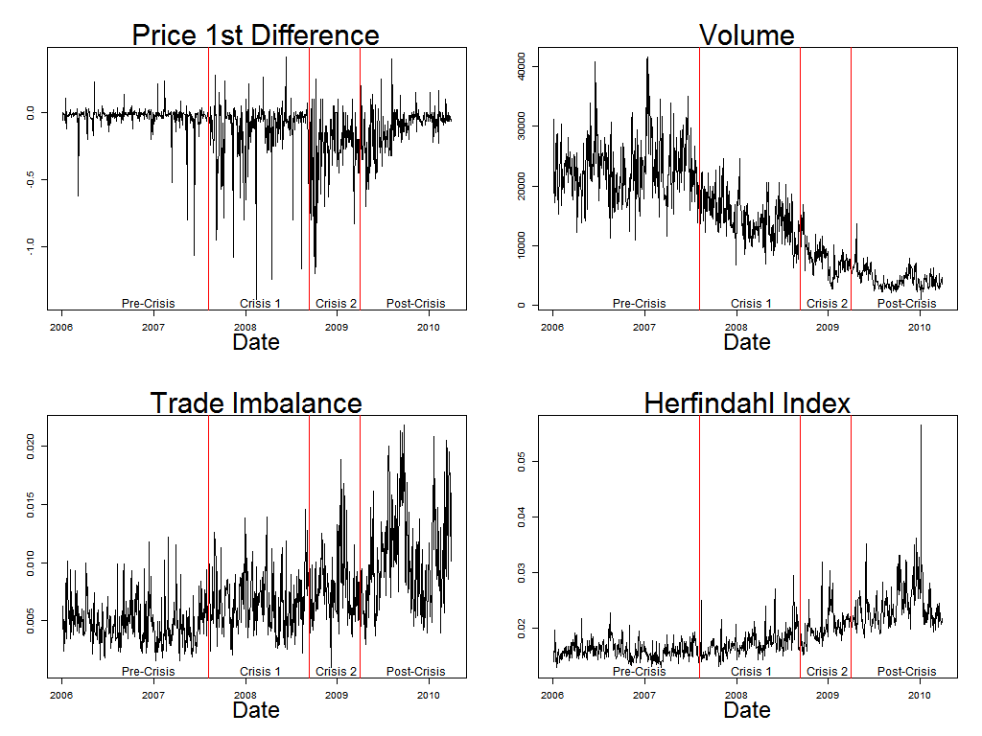

Figure 2: Measures of interconnectedness using monthly networks
(with statistics smoothed using local polynomial regression)

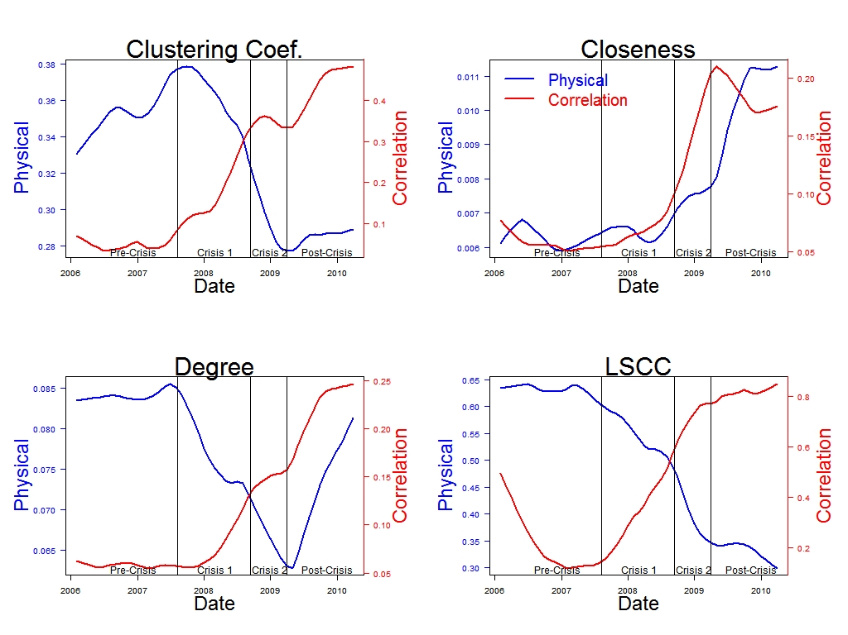

Figure 3: Time-series of network statistics and corresponding graphs

Correlation Network
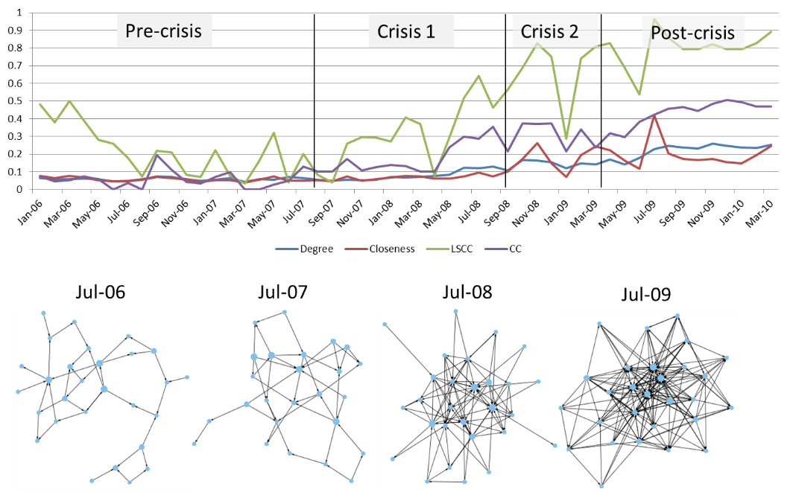

Physical Network
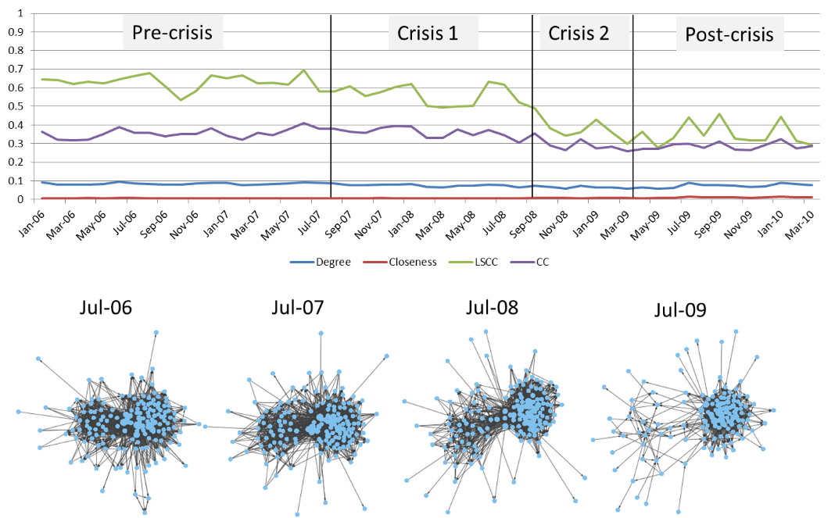

Figure 4: Directed bank (node) centrality measures, each trajectory corresponds to a different bank. Four different banks with interesting trajectories are colored.

Correlation Network
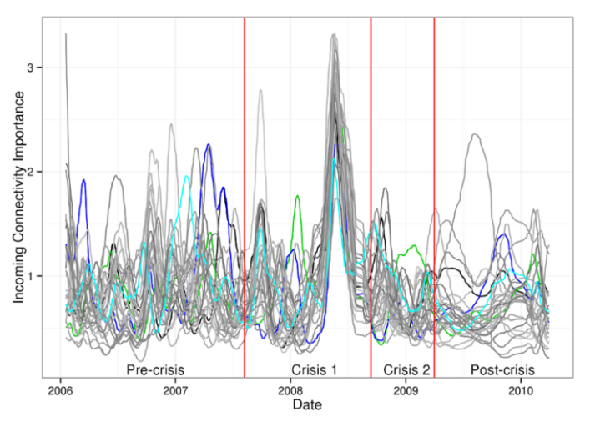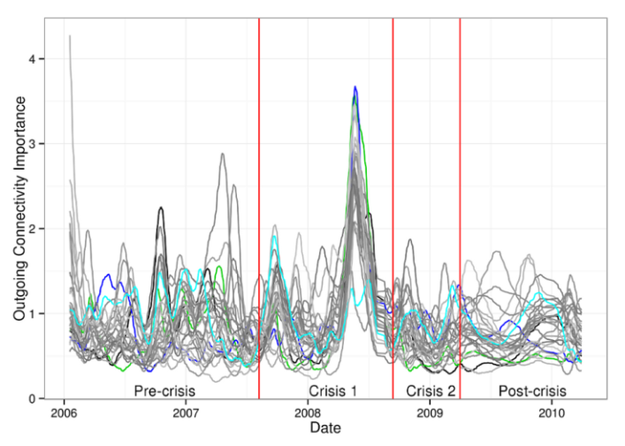

Physical Network
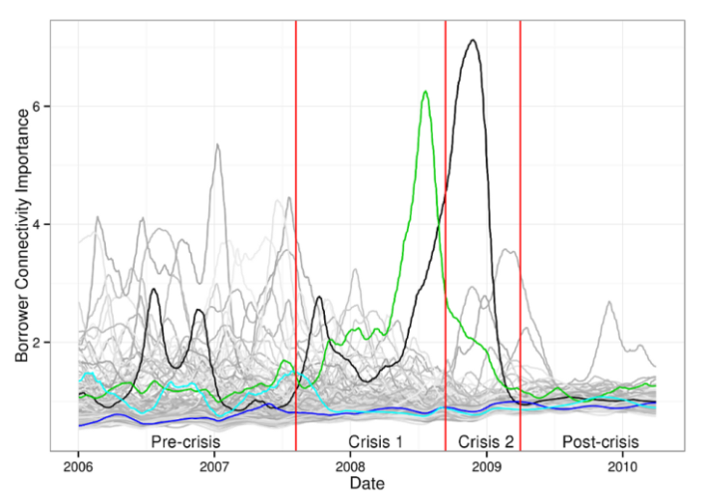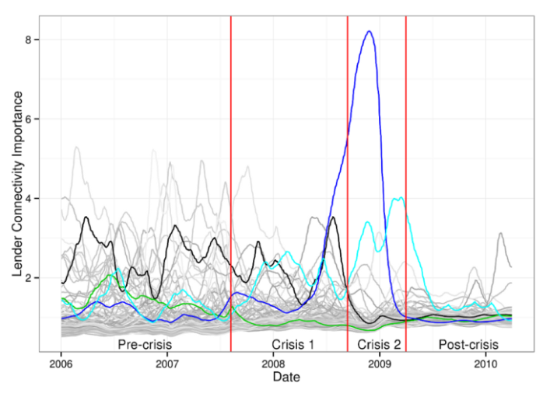

Figure 5: R² for the regressions in Equation (12)

$$y_{t+k}=α+ β_{1}U_{t}+β_{2}S_{t}+β_{3}DJST_{t}+ β_{4}{EONIA}_{t}+ β_{5}LTRO_{t}+ β_{6}MRO_{t}+ β_{7}OT_{t}+γy_{t-1}+ ε_{t}$$
where $y_{t+k}$ represents network statistics (closeness, clustering coefficient, degree and LSCC), $U_{t}$ is economic uncertainty index, $S_{t}$ is the economic surprise index (see, Scotti (2013)),$DJST_{t}$ is the DJ Europe stock index, ${EONIA}_{t}$ is the libor, $LTRO_{t}$ is a dummy for ECB Long Term Refinancing Operations announcements, $MRO_{t}$ is a dummy for ECB Main Refinancing Operations, and $OT_{t}$ is a dummy for Other Type of ECB operations.
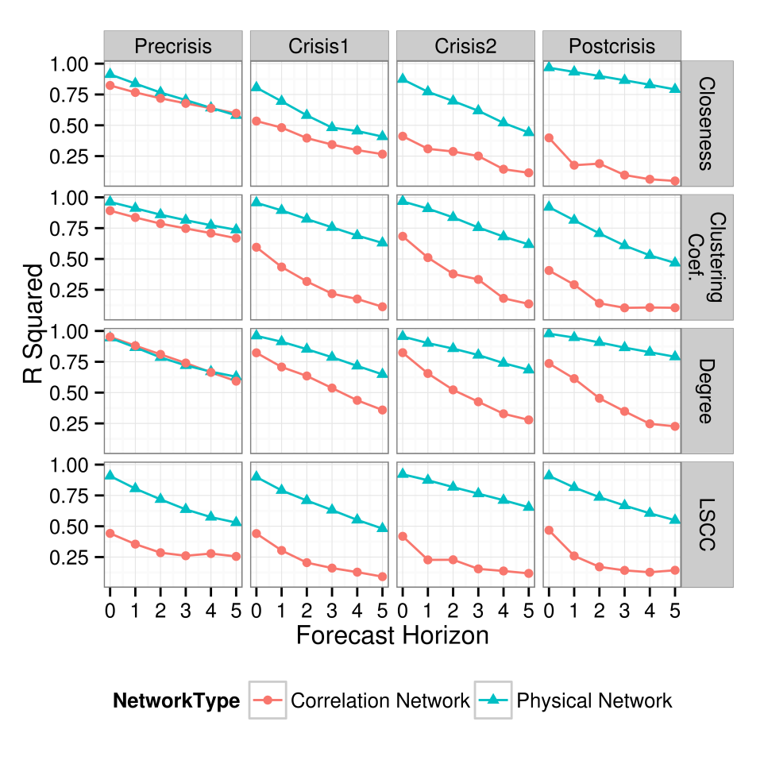

Figure 6: Estimated coefficients from the regressions in Equation (12)
The left panel shows estimated coefficients for the correlation network and the right panel shows estimated coefficients for the physical network. All variables have been normalized.

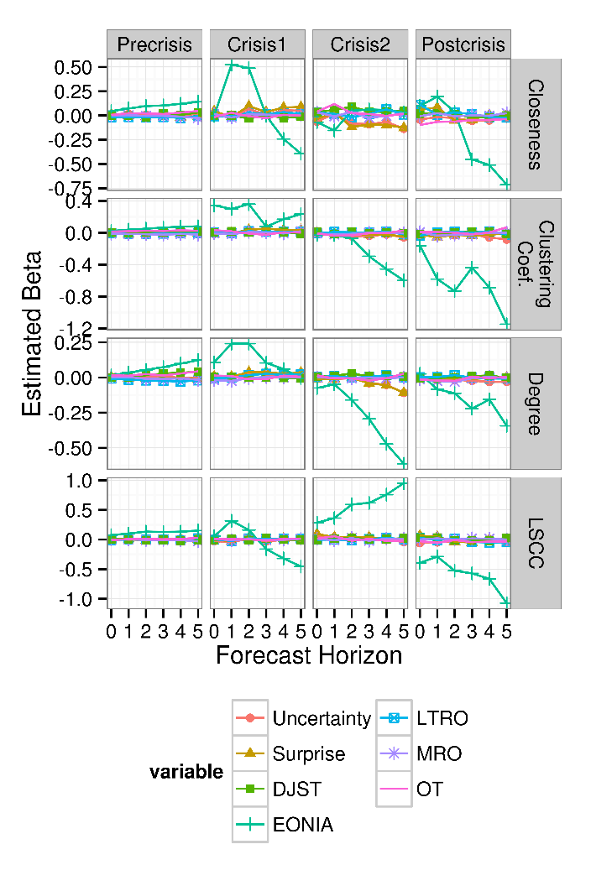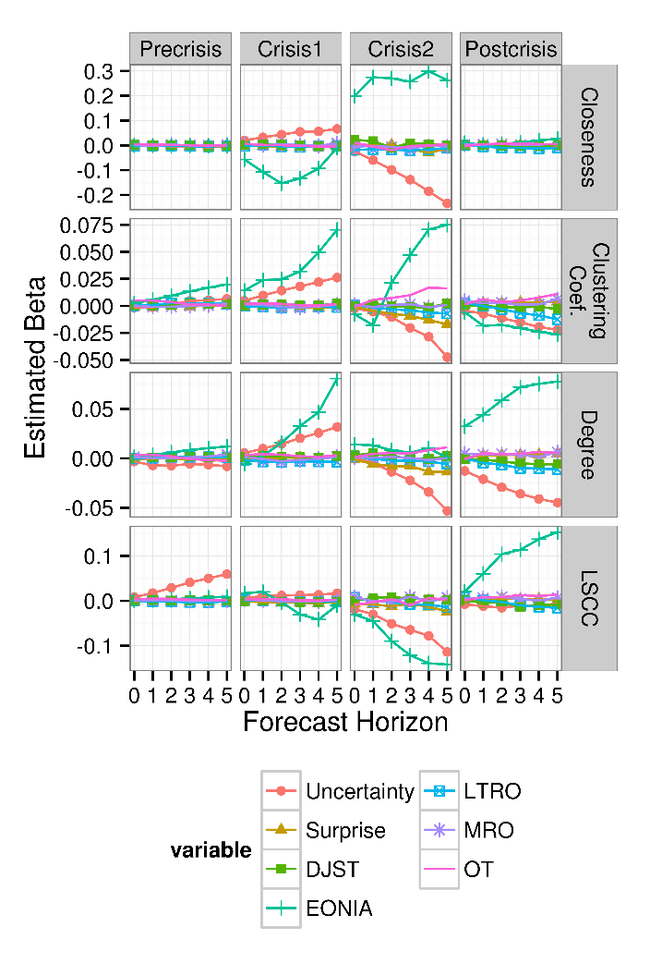

Figure 7: Partial R² values from the regressions in Equation (12)
The left panel shows the partial R2 values for the regressions of central banks announcements conditional on macro shocks on the network structure.

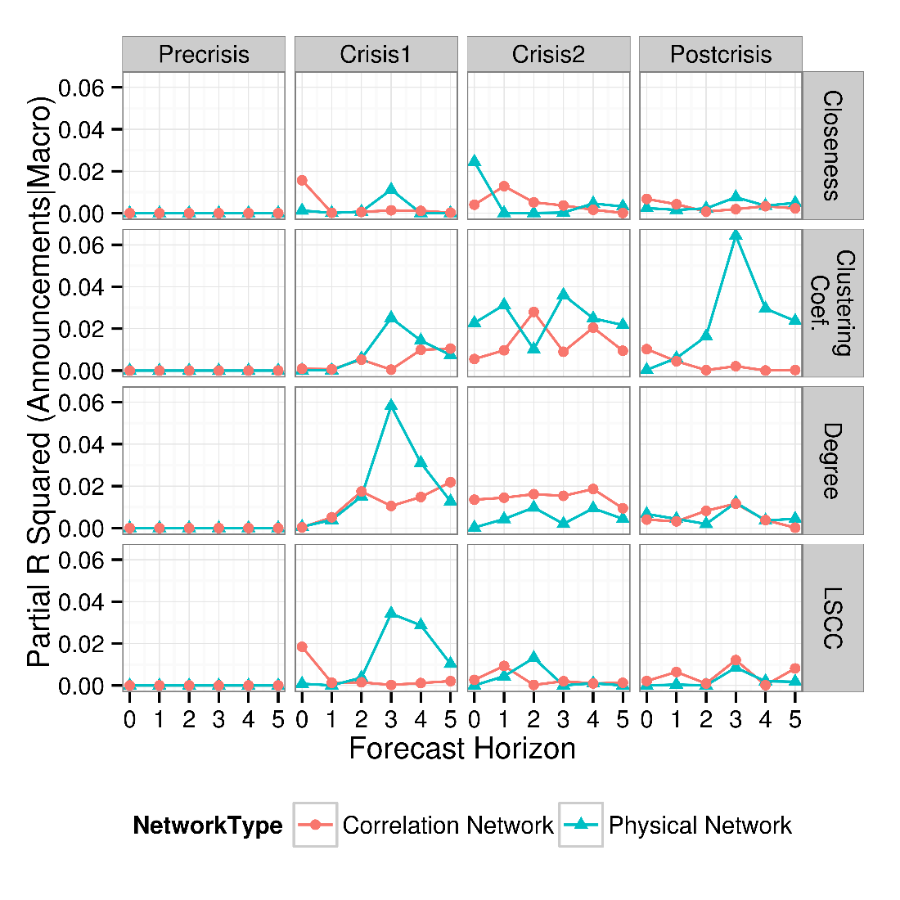

Figure 8: P-values from F-Tests for the regressions in Equation (12)
The left panel shows the p-value for the test statistic corresponding to the null hypothesis $H_{0}: β_{1}=β_{2}=β_{3}=β_{4}=0$ – macro shocks do not affect the network structure. The right panel shows the p-value for the test-statistic corresponding to $H_{0}: β_{5}=β_{6}=β_{7}=0$ –ECB interventions do not affect the network structure.

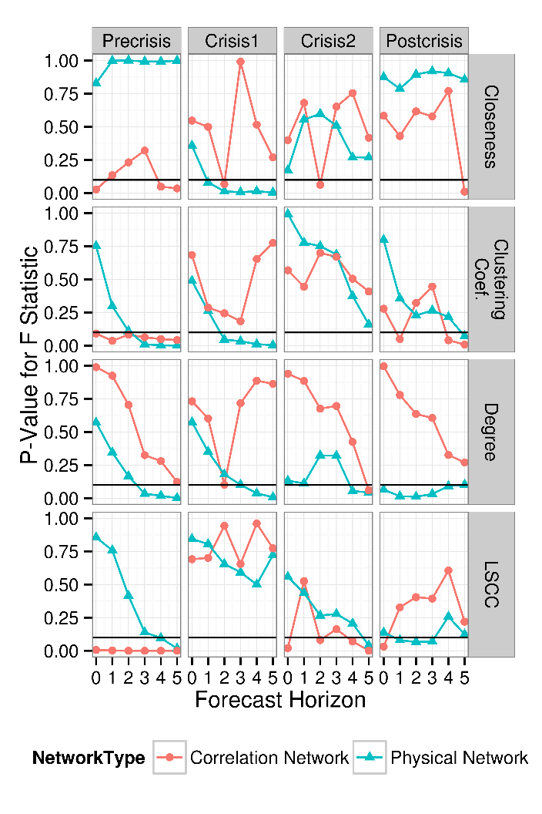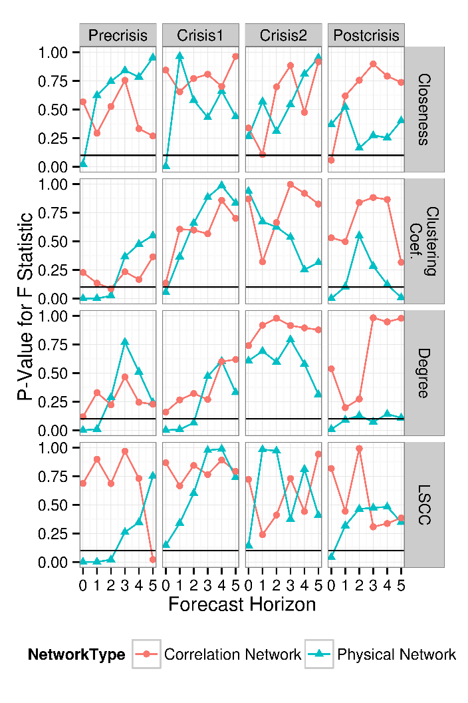

Figure 9: Partial R² values from the regressions in Equation (12)
The left panel shows the partial R2 values for the regressions of central bank interventions (operations) conditional on macro shocks on the network structure.
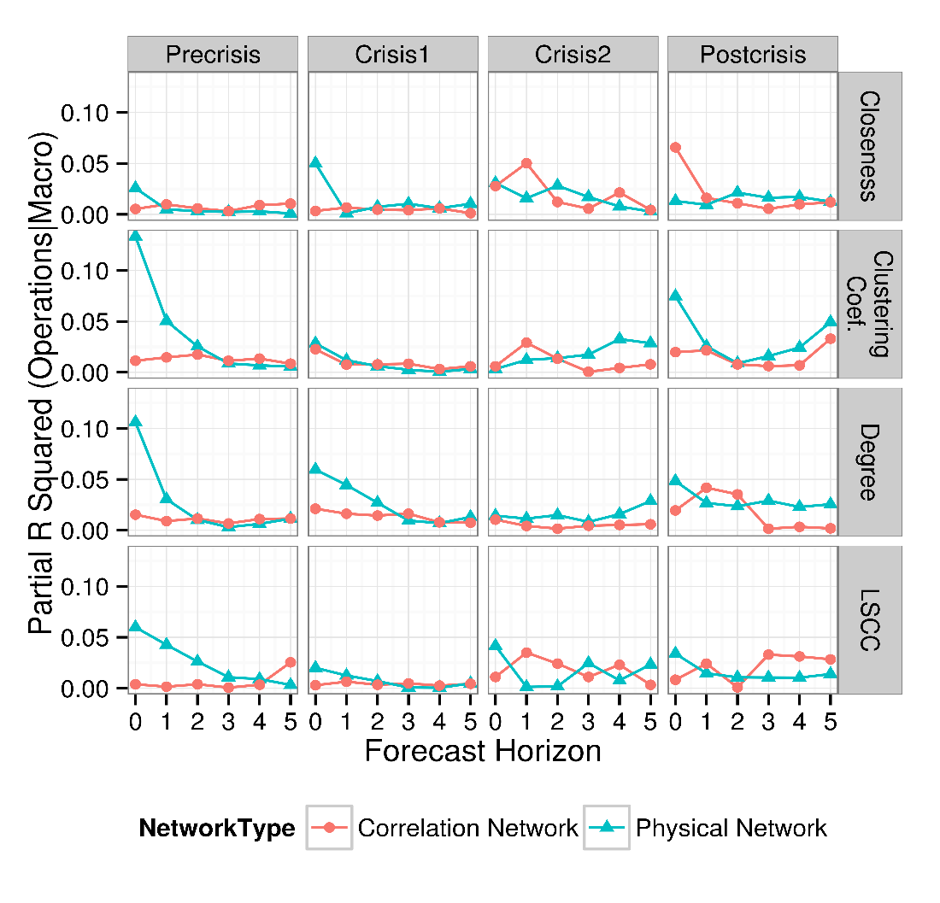
Figure 10: P-values from Conditional Tests for the regressions in Equations (15)
The figure shows the p-value for the test statistic corresponding to the partial regression null hypothesis $H_{0}: β_{5}=β_{6}=β_{7}=0 | β_{1},β_{2},β_{3}, β_{4}≠ 0$ – ECB interventions do not affect the network structure conditional on the macroeconomic variables.

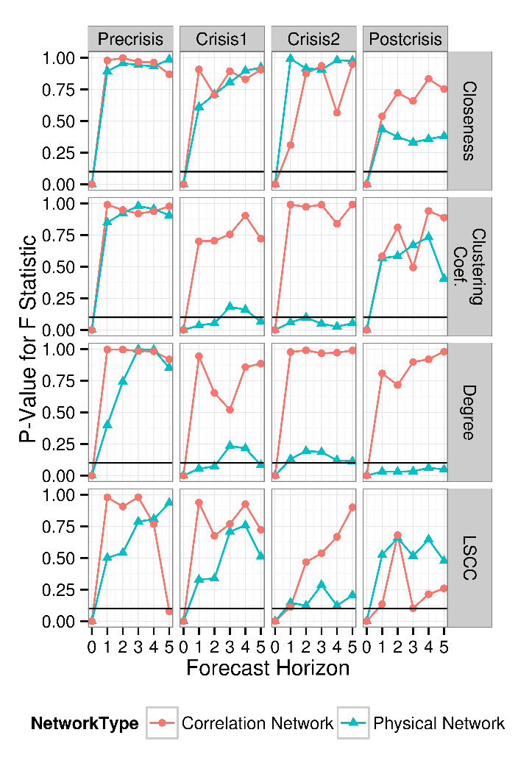

Appendix
Let $A_{t}$ be the network adjacency matrix at time t. Then the given network sequence can be approximated with
$A_{t}≈U_{t}V_{t}^{T}$,

where $U_{t}$ and $V_{t}$ are both vectors that are constrained to be non-negative, i.e., each element of $U_{t}$ and $V_{t}$ is greater than or equal to zero. Interpretations of $U_{t}$ and $V_{t}$ are straight-forward. The j-th element of $U_{t}$ measures the importance of bank j to average outgoing connectivity at time t. Likewise, the j-th element of $V_{t}$ measures the importance of bank j to the average incoming connectivity at time t. Together, $U_{t}$ and $V_{t}$ are useful for highlighting banks by their importance to interconnectivity.

Constraints that force evolving factors $U_{t}$ and $V_{t}$ to exhibit temporal smoothness are imposed on the factorizations to enhance their visualization and interpretability. This ensures that bank trajectories are visually smooth when drawn, and as a consequence, time plots of each bank become informative. Thus, centrality measures over time are found by minimizing an objective function that consists of a goodness of fit component and a smoothness penalty

$\min_{\{U_{t}, V_{t}\}}{\sum_{t=1}^{T}{{|\left|A_{t}-U_{t}V_{t}^{T}\right||}_{F}^{2}+λ_{1}\sum_{t=2}^{T}{{|\left|U_{t}-U_{t-1}\right||}_{F}^{2}+ }λ_{2}\sum_{t=2}^{T}{{|\left|V_{t}-V_{t-1}\right||}_{F}^{2} }}}$,

where the parameters $λ_{1}$ and $λ_{2}$ are set by the user to control the amount of memory or smoothness in the factors over time, and $U_{t}$ and $V_{t}$ are both vectors that are constrained to be non-negative. The interpretation is again intuitive. For the physical network, $U_{t}$ measures importance to selling (outgoing edges) and $V_{t}$ to buying (incoming edges). For the correlation network, $U_{t}$ measures importance of banks whose returns are predictive of other bank returns (outgoing edges), and $V_{t}$ to banks whose stock returns are predicted by other banks’ stock returns (incoming edges).

To minimize the objective function and obtain the centrality measures, gradient descent algorithms standard for matrix factorization can be utilized. Extensive discussion, including estimation and other implementation details, can be found in Mankad and Michailidis (2013) and Mankad, Michailidis, and Brunetti (2014).

See, for instance, Acharya, Shin, and Yorulmazer (2010), Heider, Hoerova, and Holthausen (2010, Ashcraft, McAndrews and Skeie (2011), Acharya and Skeie (2011), and Acharya and Merrouche (2012).
Interconnectedness is one of the five (equally-important) characteristics used by the European Union to determine globally systemic important banks, or G-SIBs (BIS (2011)).
See Puliga, Caldarelli and Battiston (2014).
See also Upper (2006).
See also Allen and Babus (2010) and Allen, Babus and Carletti (2010). In related work Roukny, Bersini, Pirotte, Caldarelli and Battiston (2013) analyze bank network topology and find that topology matters only when the market is illiquid.
We assume that banks have restrictions for cross holdings of equities. This assumption can be easily relaxed in our model.
Equation (6) has an interpretation similar to that in Elliott et al. (2014) and is based on the results in Brioschi, Buzzacchi and Colombo (1989) and Fedenia, Hodder and Triantis (1994). De Vries (2005) offers an interesting interpretation of (6): “The fortunes of the banking sector as indicated by the balance sheet items, are sooner or later also reflected in the value of bank equity. This enables us to characterize systemic failure in terms of the joint bank equity price movements, which are driven by the interdependent bank portfolios.” (p.2).
Barigozzi and Brownlees (2013) construct networks where edges are based on long run partial correlations. Likewise, Diebold and Yilmaz (2014) propose several measures of interconnectedness based on the decomposition of the variance-covariance matrix. They show that these measures of interconnectedness are linked to key measures of connectedness used in the network literature.
Moreover, Granger-causality networks require longer sample periods since they are the result of an estimation procedure.
The e-MID platform is the only electronic market for interbank deposits in the Euro region and offers a comprehensive view of interbank loans ranging from overnight (one day) to two years in duration, with overnight contracts representing about 90% of the total volume during our sample period (see Brunetti, diFillippo and Harris (2011)). The e-Mid web page currently notes “According to the ‘Euro Money Market Study 2006’ published by the European Central Bank in February 2007, e-MID accounts for 17% of total turnover in unsecured money market in the Euro Area.” European banks also trade bilaterally, via phone brokers, and with the European Central Bank directly
Recent works in network analysis show that metrics calculated from partial networks can have significant bias and loss of information For instance, Achlioptas et al. (2009) show that sampling a network according to a breadth-first search leads to graphs that have biased properties. Handcock and Giles (2009) also show that partially-observed network data can be used for valid statistical inference, but only under special sampling schemes that would be violated if we retain only the 29 banks. Similarly, Chandrasekaran, Parrilo, and Willsky (2012) show that working with partial data often leads to bias for correlation networks.
The European crisis became more severe in 2011 and 2012 with very large Euro-area bank CDS premia and sovereign bond spreads for Greece, Ireland, Portugal, Spain and Italy relative to Germany.
Other research analyzing e-MID data in the context of network analysis includes Hatzopoulos, Iori, Mantegna, Micciche and Tumminello (2014), Iori, Mantegna, Marotta, Micciche', Porter and Tumminello (2014), Roukny, Bersini, Pirotte, Caldarelli and Battiston (2013), and Delpini, Battiston, Riccaboni, Gabbi, Pammolli, Caldarelli (2013).
Trade imbalance is computed as the difference between number of buys and number of sells, normalized by volume.
Signed volume is computed as the difference between aggressive buy volume and aggressive sell volume.
Since interbank trades are directly observed, our physical network is more similar to social networks, where a relationship exists between nodes (see Newman (2010) and Jackson (2010)).
Weighting the edge in the physical network by volume does not change our main findings.
Similar results are obtained from the daily sampling frequency.
The key idea is to estimate a sequence of low-rank matrix decompositions of the adjacency matrix at each point in time to discover low-rank latent structure that characterizes the dynamics of the network. We briefly review this technique in the appendix.
These data are available from the ECB website.
The indices, on a given day, are weighted averages of the surprises or squared surprises from a set of macro releases, where the weights depend on the contribution of the associated real activity indicator to a business condition index.
The announcements variable is constructed from Rogers, Scotti and Wright (2014) Table 3 data.
Results for equation (13) are very similar.
Similar results are obtained when estimating equation (13).
Bloom (2009), e.g., shows that higher uncertainty causes firms to reduce investment and to hire fewer workers. Leduc and Liu (2012) provide evidence that uncertainty in the recent crisis has reduced economic activity and incrementally increased US unemployment by more than one percent.
We obtain similar results when analyzing F-tests for the macro and ECB shocks in equation (13) where ECB shocks refer to ECB conventional and unconventional monetary policy announcements.
Similar results are obtained for test-statistic corresponding to the partial regression null hypothesis $H_{0}: β_{5}=0| β_{1},β_{2},β_{3}, β_{4}≠ 0$ in equation (16).

